30th June 2022

Dear Parent / Carer,
Year 12 Work Experience
WC 12 Dec 2022 and WC 26 June 2023
As part of their career exploration and planning, all year 12 students will be participating in work experience. ­They will have the opportunity to spend two separate weeks out working with employers. It is expected that they complete both weeks out at a suitable setting.
Students are responsible for making initial contact with potential providers / employers after discussion with parents in order to approach placements which may link with their courses at the Academy, and / or which hold a particular interest for them.
Consideration should be given to any travel arrangements, as they will need to make their own way during the week. Please note, Sole Traders (people who work on their own) will not be accepted as a placement as they will not have the correct Employers Liability Insurance (£5m) to cover Work Experience students.
When a placement has been agreed with an employer, the employer should complete and sign the form overleaf, then detach & keep the bottom half and the student then returns the top half to Mr Wall.
We will ensure all placements are Risk Assessed in order to maintain the Health and Safety of your son/daughter but this process can take some time (up to 8 weeks) as it is undertaken by the Education Business Partnership (EBP) – Wolverhampton.
Thank you in anticipation of your help in making your son/daughter’s Work Placement an enjoyable and memorable experience.

Yours sincerely,

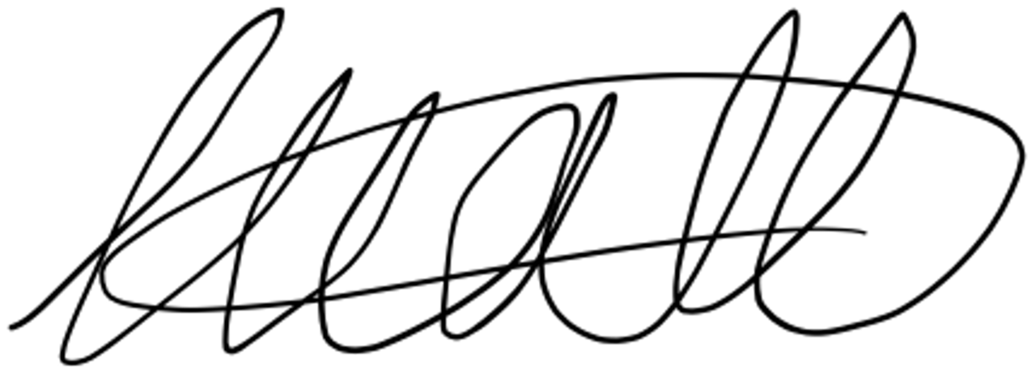
Mr Wall
Careers Adviser
Lwall@oswba.co.uk (01902 493797)

Year 12 Work Experience 2022-23
SWB6th Copy – Please give to Mr Wall

The following Business / Company have agreed to take me for Work Experience on ______________
TO BE COMPLETED BY EMPLOYER
Business / Company Name ___________________________________________________________
Type of work to be undertaken by the student ______________________________________________
Address ________________________________________________________________________________
Postcode ________________________
Telephone ______________________________
Email Address ________________________________________________________________________
Name of contact (BLOCK LETTERS please) ___________________________________________________
Signature of contact ______________________________________________
Employer Copy (Student to give to Business / Company for their records)
Year 12 Work Experience
Thank you for agreeing to provide Work Experience for one of our students
Student Name ____________________________________________________________________
Dates ______________________________________________________
You may be contacted about this placement & confirmation sent, however, should you wish to contact us directly please use the number below.
Mr Wall
Careers Advisor
Lwall@oswba.co.uk (01902 493797)

PLEASE ENSURE YOU HAVE COMPLETED THE SECTION IN BOLD ABOVE (SWBA copy), THANK YOU

